**IMPLEMENTATION OF AN INSTRUCTOR PACED LEARNING APPLICATION USING ADAPTIVE LEARNING TECHNIQUES**

**BY**

**OJO,** OLUWAFISAYOMI DORCAS

(17CG023195)

**A PROJECT SUBMITTED TO THE DEPARTMENT OF COMPUTER AND INFORMATION SCIENCES, COLLEGE OF SCIENCE AND TECHNOLOGY, COVENANT UNIVERSITY OTA, OGUN STATE.**

**IN PARTIAL FULFILMENT OF THE REQUIREMENTS FOR THE AWARD OF THE BACHELOR OF SCIENCE (HONOURS) DEGREE IN COMPUTER SCIENCE**

**MARCH 2021**

# CHAPTER ONE

# INTRODUCTION

## BACKGROUND INFORMATION

Ages 0-8 are known as the formative years of a child’s life ((AEDC), 2017). It can also be referred to as the period of early childhood. This period marks a significant aspect of a child’s life because it has a serious effect on overall development of a child. The early years of a child mark the beginning of their development and serves as a foundation for learning, cognitive, emotional, and social development throughout their lifetime (University, 2021). The formative years have a profound effect on a child’s future. During the period of early childhood, children start learning about how the world works and the progress they make in this phase of their life sets precedence for future achievements later in life (Institute of Medicine and the National Research Council, 2015).

Due to the fact that early childhood is a period of rapid development in a child’s life (Tout et al., 2013). It is important to introduce quality education at this stage. Education is very important and key to a successful future. It exposes the mind and unlocks the door to many opportunities. Education is the process of learning skills and gaining new knowledge. It is important to educate children because they will one day grow up to become leaders and they must be equipped to run the society when the time comes. Education involves exposing a child to necessary materials and activities needed for their growth per time. In the early childhood one aspect of education every child should be exposed to is acquisition of literacy skills.

Literacy is simply the ability to read and write. Inability to read and write will lead to difficulty in navigating the world. An illiterate will not be able to read through a grocery list, read road signs, read newspapers, and fill forms. It will be impossible to go through life without constantly being dependent on someone to assist with interpretation of written information. The importance of literacy skills cannot be over-emphasized because you need it to make sense of the world around you. If a child never learnt to read and write, the child will not be able to succeed at school. Later in life, it will be impossible to land high skilled job because they require that you have the basic literacy skills (National Literacy Trust, 2017).

Literacy is so important and that is why it is entrenched in our fundamental human right to education (Sanchez & Frandell, 2013). It involves the foundation of reading, writing, understanding, and calculating simple sums. Since these foundational skills are needed for an individual to exercise their fundamental right to education, it can be said to be an essential right. Literacy increases the probability of a positive outcome later in life. Literacy skills empower you with basic knowledge needed to achieve other societal goals e.g. eradication of poverty, child mortality (Adewusi & Nwokocha, 2018) and reduction of population growth (Population Action International, 2011). Child mortality is lower amongst educated mothers because literacy enables them access important information. Literate women are likely to have smaller families in comparison to other women.

Literacy skills reduce your chances of being incarcerated. Studies show that in the United States, lack of access to education contributes majorly to incarceration rate, when the libraries in areas with low education were funded it was also discovered that library funding significantly decreased the crime rate (Libraries 2020, 2020). Children who have illiterate parents, may not be motivated to perform well in school. Illiterate adults are likely to be unemployed and lack of employment increases the probability to turn to crime. Studies have shown that young adults with low literacy skills are likely to end up in jail and have a high childhood of returning back to prison post incarceration (O’Cummings et al., 2010).

Youths with poor academic records are 3.1 times likely to join gangs and gang members usually engage in delinquent behavior (O’Cummings et al., 2010). Literacy affects every sphere of life. Illiteracy leads to unemployment (Roman, 2004). The devastating effects of illiteracy also extends to the health sector. Research shows that illiterate adults usually have poor health. Even when prescribed drugs by a physician to treat an ailment, inability to read the instructions could lead to an overdose. Illiterate usually lack health insurance and have no access to basic health education (Baker et al., 1997). A country with a high percentage of illiterates will have soaring crime rates and a large dependent population because majority of her citizens will be unemployed.

To prevent all the many disadvantages of illiteracy, children are educated during their early years so that they get it right from early on. The child is taught the fundamentals of writing, reading, understanding and communication. A good writer must be able to spell, and a good reader must be able to write (Ingebrand, 2013). Spelling lies at the heart of both literacy skills. The concept of spelling and reading rely on the same fundamental principle (Moats, 2005). Spelling involves the ability to understand the relationship between letters and sounds. Understanding of how word pronunciation work improves communication (Learning, 2017).It helps you write and read better because it is a foundational skill for those literacy skills. For examples letters and sounds form words. Words form sentences, Sentences for paragraphs etc.

Spelling also affects your chances in a job. For example: Nobody is likely to employ someone with a CV that is filled with spelling errors. The candidate will not appear serious for the job Even if you forgive, employers sometimes use Applicant Training Systems, and these systems have no mercy when scanning through applications. There has been an argument that spell checkers have been invented and that the spell checkers will replace spelling, while it’s true that they work, a spell checker does not catch all errors and bad spellers do not suggest a spelling close to the correct word (Moats, 2005). In fact, a research carried out by (Montgomery et al., 2001) shows that spell checkers only catch 30 to 80 percent error and that they are only able to identify misspellings of children with disabilities 53 percent of the time.

Spelling involves the ability to recognize, recall, reproduce and obtain in written or in oral form the correct sequence of letters in words (Graham & Miller, 1979). Spelling of a word can be deciphered in a number of ways (Moats, 2005) which include: The language of origin of speech can be examined to determine the spelling of a word can be used to explain its spelling, the spelling of a word can be determined through its meaning and part of speech, the knowledge of how speech sounds are spelt and lastly the spelling of certain sounds is governed by established rules of how letter patterns work. Spelling helps in building confidence of the learners and provides them with needed language tools to properly express themselves at every point in time. Letter-sound correspondence can sometimes be tricky but ability to understand it will make one a confident communicator.

Spelling also relies on the application of linguistic knowledge and the knowledge of letter-sound correspondence and vowels too (Reading Rockets, 2021). Although spelling is not the most important aspect of writing, it is a vital part of it (Simonsen & Gunter, 2001). This is because good spellers can express themselves properly on paper without stress. Poor spellers on the other hand are limited to a word range containing words they are conversant with. Traditional method of practicing spelling in a classroom usually involves a teacher dictating the word to the students in a class. In the last few years there has been an improvement in technology, from robots to electric cars etc. It is expected that this development should extend to the software aspects of tech. Various applications are being developed daily to solve problems and improve lives.

To improve spelling, mobile applications have been developed on the play store and apple store, respectively. Studies have shown that the use of mobile devices, in this case the iPad encouraged reading, learning and cooperation in class (Victoria University, 2014). Recent e-learning platforms have started integrating a personalized learning technique known as adaptive learning. It involves the use of technology in delivering custom learning experience that addresses the unique needs of the learner. It relies on data gotten from users’ interaction with the application. To integrate the adaptive learning platform an algorithm is used to build a model that makes fast predictions. The model will predict learner’s ability to answer the question using data of learner’s performance.

One of the benefits of adaptive learning is that it can provide feedback on learners’ performance. The feedback allows teachers and parents to identify areas that need improvement and work together to help the child improve. Research also shows that family involvement in school activities has a positive impact on children (Dearing et al., 2006). Adaptive Learning ensures the aspect of the material learner does not understand is repeated as many times as possible until he learns it (Forsyth et al., 2016). As earlier discussed, many spelling applications have been developed but these applications do not allow Instructors in this case teachers and parents set target words for their child to spell. Although, adaptive learning provides feedback, the feedback form currently in use is in terms of the next content presented to learner. There is no such thing as a comprehensive report to instructors. These has birthed a need for a platform that solves this problem.

## STATEMENT OF PROBLEM

Parents and guardians provide their wards access to literacy skills by enrolling them in a school to be taught by competent teachers; the parents do their own “teaching” by engaging children in literacy-related activities at home. Together, parents and teachers serve as instructors for the child. Literacy is a determinant for success later in life (Leahy & Fitzpatrick, 2017). Literacy skills involve the ability to read and write and spelling is vital to these two skills. Spelling provides a child with a wide range of words that propels the acquisition of other literacy skills. Over the years, there has been a rise of mobile technology and because of the many benefits it has been integrated in classrooms and used in the home to facilitate learning.

As expected, there are mobile applications that have been developed on mobile devices to help children learn to spell for example Word Wagon, Freefall Spelling etc. However, these mobile applications are based on a predetermined curriculum built-in by the developer and do not provide feedback to the teachers as well as the parents. Curriculum flexibility is important because it will enable instructors (parents, teachers, and guardians) set learning goals for the learner based on learner’s learning needs. Feedback based on adaptive learning algorithm provides teachers and parents with information towards improving the learning outcome. Hence, the need for Spelling app that integrates both curriculum flexibility and performance feedback.

## AIM AND OBJECTIVE OF STUDY

The aim of this research is the implementation of an instructor paced spelling app that uses adaptive learning techniques.

It is impossible to achieve these without the following objectives:

1. To review existing literature on adaptive learning techniques and determine its applicability for the proposed spelling app. In addition, to survey existing spelling apps to better understand how to conceptualize the idea.
2. To design a model of a spelling app based on adaptive learning techniques.
3. To implement a prototype of an adaptive spelling app as proof of concept based on the model.
4. To evaluate the usability of the prototype using standard usability metrics.

## METHODOLOGY

These include the various activities, models, tools, and methods to be used in achieving each objective. They are:

1. **Objective 1: *To literature review and survey of existing applications.***

In other to review existing applications, spelling applications on the apple store and play store will be reviewed, respectively. The applications will be compared to discover new ways to better approach the project or advance the project. Inferences will also be drawn, and other methodologies will be based on the resulting analysis from this comparative review. Articles from Scopus, ScienceDirect and Springer will also be reviewed to extract the theories, techniques, and psychological basis for spelling.

1. **Objective 2: *To design a model.***

The model that will be designed to fulfill this objective is an activity diagram. It is a UML diagram designed to represent the flow of a user from one activity in the system to another. A UML diagram is used to visually represent a system and includes actors, actions, and classes. This methodology will also include the use of a Naïve Bayes algorithm which is an adaptive learning algorithm used to build models that make fast predictions. The model will be used to determine the next word to present to the learner based on learner’s previous performance.

1. **Objective 3: *To implement a prototype to show proof of concept based on the model.***

The prototype (activity diagram) is implemented using React JS for the front end, Python (Django) for the back end and My SQL database to store data for the system. The system is tested to ensure the code does not break in production and that the system is working according to what was designed in the prototype. Additional features are also added if there is new discovery during testing and evaluation of user experience.

1. **Objective 4: *To evaluate user experience.***

The finished application is evaluated by getting kids between the ages of 0-8 years and their instructors to try out the application. Their experience starting from usability and ease of navigating the application to them getting comprehensive performance reports is also noted. This is done using PSSUQ (Post-study system Usability Questionnaire) which is a 16-item standardized questionnaire used to record user’s satisfaction.

## SIGNIFICANCE OF THE STUDY

One way or another the world is dependent on the education of children. The wonderful people doing great things e.g. Bishop David Oyedepo, Elon Musk and Mark Zuckerberg etc were once children. They will not be able to impact the world if they ended up in jail or have no literacy skills. The completion of this theses is beneficial and of great importance for the following reasons:

i. The implementation of this project will help children develop great spelling skills which will make them good readers and serve as a bedrock for academic success later in life.

ii. The fulfillment the child gets from completing the assigned words for a given period will help them learn the rewards of hard work and to persevere in bigger challenges later in life (Baranek, 1996).

iii. Gifted children will also be identified by their parents and nurtured by virtue of them meeting the target words in a faster duration than their peers.

iv. The comprehensive feedback will help teachers and parents create a synergy towards the acquisition of quality education of the child.

v. It will help to better utilize idle time and nurture healthy study habits which will have a resultant effect on academic success later in children’s life.

## LIMITATIONS OF THE STUDY

The spelling application assumes some conditions:

The constraints include:

1. This study does not make provision for lapses in human error which may result from inaccurate data during the evaluation phase.
2. If parents and tutors do not give accurate feedback the outcome of the study will be incorrect.
3. Safe assumptions are made that whatever data is inputted as feedback is done in good faith and accurate.

## PROJECT ORGANIZATION

In this project, Chapter One contains the project’s background, the domain areas, the issues being solved, objectives and aims of the research, the methodology used in carrying out the objectives, the significant of the study and limitations.

Chapter Two provides a summary of the relevant literature, comparative review of existing systems and an overview of the instructor paced learning application that uses adaptive learning techniques, system theory and concepts.

Chapter Three covers the methodology used in the implementation of this project.

Chapter Four contains the processes involved in system implementation of this project.

Chapter Five contains the summary, suggestion, and conclusion of the project.

# CHAPTER TWO

# LITERATURE REVIEW

## INRODUCTION TO CONCEPT OF LEARNING

Learning is the process of gaining knowledge, skills, and values etc. To understand how humans learn we need to understand how the brain works. The brain is the center for control of the human body. The brain directs the activities in the body by making sense out of the information it receives from the rest of the sense organs. The brain adjusts according to response from its environment and this process is known as plasticity (OECD, 2008). It involves creation and strengthening of neuronal connections and killing some off or weakening some. Whenever we learn new stuff the brain re-structures by creating new neural pathways. Neural pathways are series of linked neurons used for sending signals between different part of the brain. The brain carries out synaptic pruning to clear away unused neural pathways in the brain.

Memory formation occurs when we review and practice what we have learnt. Neurons in the brain are tasked with forging information into memories. They do this by sending messages to other neurons. All the information being exchanged and the connections between the neuron that carry them form memories. When you practice something you know, dendrites grow between neurons that hold that memory. As you keep reviewing that knowledge by practicing, application of that knowledge to solve a problem and application to a different subject area this process increases the activity that goes on between neurons thus fortifying the memory. For example: repeatedly studying the alphabets, applying knowledge of words to build sentences strengthens the networks and makes the memory permanent. This process is like tightening of a screw multiple times, so it stays in place.

The process of learning is what we know as education and there are three types: Formal, Informal, and Non-formal. Formal education is education from an institution. Informal education is done outside the traditional classroom and it is paced by the learner. Non-formal includes learning from experience, from home and environment. This thesis is focused on children between the ages of 0-8 and as such we will not be dealing with informal education. This is because children at this age will need instructors to guide them, be it their parents or teachers. There are many teaching methods some of which include: Direct instruction, Kinesthetic learning, and personalized learning etc. But this thesis is spotlighting a personalized learning method approach which is known as adaptive learning. Adaptive learning is built on the premise that learning is not a one size fit all. Students do not react the same upon interaction with their teacher (Matei & Gogu, 2017). Some may need more encouragement, examples etc. To efficiently teach, the teacher will need to adapt their methods, but it will never reach peak efficiency as he may not be able to meet the needs of each student.

Adaptive learning solves that problem through the use of technology to track students’ progress and structure the instruction by using student’s data ((Graham & Miller, 1979). Adaptive learning makes us of data that shows how the learner’s think to structure learning material that is unique to each learner. Adaptive learning improves how children by providing feedback (Roschelle et al., 2000). The feedback is provided using rules defined by the developer to make sense of the data. Adaptive learning takes learner’s previous knowledge into consideration and uses it to give accurate response to their learning needs to reduce gaps in their understanding (Moskal et al., 2017). This ensures children has mastered the concept before moving to another material and that everyone is carried along. Using generated feedback instructors can visualize performance and maximize outcome. The feedback allows teachers to identify struggling students and attend to their needs which contributes to higher levels of academic success.

### Introduction to the Concept of Spelling

Children around the world are taught literacy skills because it is a foundational skill. Spelling connects and improves most literacy skills. Before a child can read or write she needs to be able to know the spelling of the words. Children’s performance in spelling assignments and tests allow their instructors have a view of how their understanding of language is progressing (Reading Rockets, 2021). It also allows provides knowledge of how well children understand the graphic and phonological characteristics of writing (Pollo et al., 2012). Spelling progress can be measured through well-defined stages which are (Reading Rockets, 2021):

1. Precommmunicative stage

In this stage have no understanding of letter-sound correspondence. The children are probably showing interest in reading and writing. They may also enjoy scribbling; this shows that they are aware of the purpose of writing which is communication.

1. Semiphonetic stage

The child gets exposed to phonetics in this stage and begins understanding phonetic letter sounds, they may be able to correctly “sound” out a given letter e.g “ah” for the /a/ sound. The phonetic understanding will also reflect in their writing and they may occasionally ignore vowels because their occurrence is not as predictable as consonants.

1. Phonetic stage

The child’s letter-sound correspondence is fully developed at this stage. The child starts to read. The child will also begin identifying the sounds commonly grouped letters make e.g. “-ly” and “-ing” etc. They may struggle with non-commonly grouped words and may invent their own spelling a few times.

1. Transitional stage

The child begins to memorize words and notices patterns. They will also learn how synonyms work and avoid use of words they are not familiar with. They will also improve in their letter-sound correspondence and make a few mistakes here and there. Previous knowledge will prove useful to them and improve their spelling.

1. Correct stage

This is the last stage, by now the child fully understand the basic rules and patterns needed to spell in the English language. They have a good range of words that they can spell correctly. They can also read books at their reading level unassisted. They can recognize spelling mistakes and can try to correct them.

A child may struggle with the five developmental stages of spelling if the material she is exposed to is substandard. An efficient and effective spelling program has to put a variety of things into consideration (Hodges, 1965), namely:

1. The British language in the case of Nigeria and the grounds on which target words are selected.
2. The child’s learning method.
3. Instructional practices that can efficiently meet the needs of the learner.

## REVIEW OF EXISTING SYSTEM

This section contains the review, features and challenges of some applications that have been developed to help children spell

### Montessorium: Intro to Words

Montessorium is an educational mobile application which applies the Montessori method to teach children how to read, write and spell. The Montessori method of teaching emphasizes hands-on independent learning and collaborative play. On this mobile app, children can listen to a narrator pronounce words and emphasize sounds of letters. Children can click on a letter and the letter sound is played out.

Instead of spelling or reading comprehension, this application places focus on the phonetic sounds used to build a word through its features like the sound game, and storyboard feature. The sound game teaches children to be familiar with letter sounds. In the game, three objects are displayed, and the narrator pronounces the first letter sound of one of the objects displayed. Children then select an object that begins with that letter sound. The storyboard feature allows children to build words on their own by sound and illustrate them with in-app stickers of various objects.

The application does not include a spelling checker, which allows children to spell phonetically without correction. This application works well with children who already know letters and letter sounds. This application is available only on iOS mobile devices (iPad, iPhones, and iPod Touch). This application costs $4.99 and does not offer a free version. This application does not have a built-in spelling curriculum and does not allow parents/teachers to input custom words. This application does not monitor learning data, nor does it provide detailed performance feedback, but children can save photos of their storyboard stories.

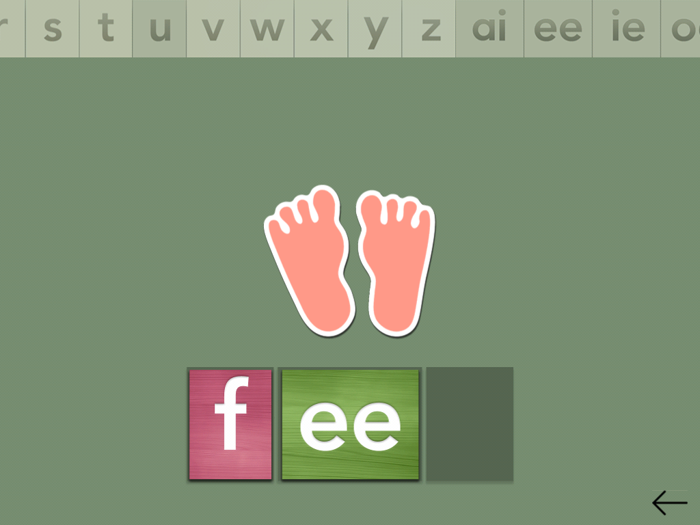

Figure 1: Phonogram feature on Montessorium

### Freefall Spelling

Freefall Spelling is an educational game which allows children to practice their spelling skills and letter recognition. It makes use of hand-drawn pictures and have three modes of play: Free fall, Type and Scramble. The application’s interface is very bright and colorful. It has a reward system which makes the application very engaging and user-friendly.

Freefall Spelling is not suitable for learning letter sounds. This application comes preloaded with 150 words which covers sports, food, animals, numbers, etc. This application is very customizable as it allows parents/teachers create custom spelling list for children to practice as well as record speech for a word, add a sample sentence and a picture. It does not however have a built-in spelling curriculum.

This application does not track data nor give comprehensive feedback on the children’s performance. This application cannot be used by multiple people on one device because rewards and scoring set by individuals are made available to all profiles. This application is only supported by Amazon Kindle Fire. This mobile game cost $1 and does not have a free version.

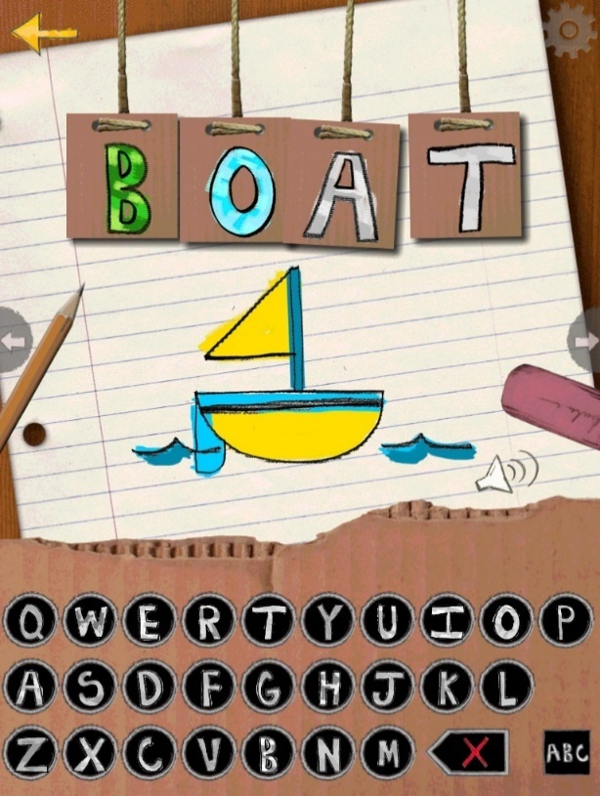

Figure : Freefall Spelling



Figure : Freefall Spelling

### Avokiddo ABC Ride

Avokiddo ABC Ride is an educational game which allows children explore letters and words creatively with series of alphabetically organized letter-related challenges, each introduced with an alliterative poem. Children choose between two characters, “Beck” and “Bo” who they help get to their destination by spelling target words in challenges that pop-up. This application also contains other mini games such as letter games and puzzles which help children further explore letters and letter sounds and build problem-solving skills.

Avokiddo contains great graphics which are very engaging for children. The app, however, is not so user-friendly as the games/challenges are not explained beyond their accompanying poem, so children must figure them out. This application does not track the children’s performance or give comprehensive feedback. This is a premium mobile application which cost $2.99 and is supported by Android and IOS devices.

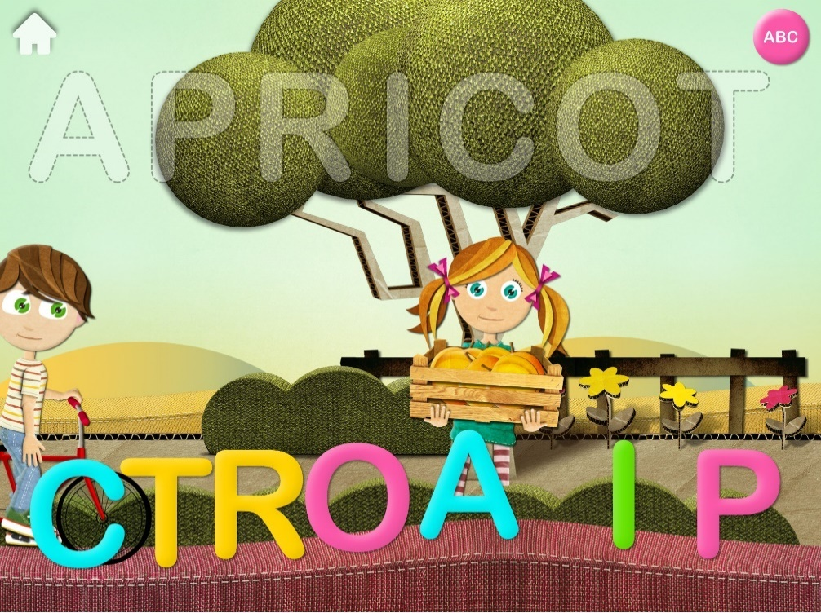

Figure : Avokiddo ABC Ride

### Word Wagon by Duck Duck Moose

Word wagon is a spelling and phonics application made by Duck Duck Moose, intended to teach new readers’ letters, phonics, and spelling. This mobile application contains colorful animation that is engaging for children within preschool to kindergarten 1. This application has a reward system (for each word they spell correctly, children win animated stickers for their virtual sticker book) and increases difficulty at every level. At the more difficulty levels, it removes all visual and audio clues, enabling the children to spell words on their own.

This app is only supported by iOS devices (iPhones, iPads, iPod touch). This application does not keep track of user progress between sessions and does not give comprehensive feedback on the user’s performance. Word wagon does not allow parents/teachers to input custom words or spelling lists, however parents/teachers can customize or curate lessons. Word wagon is free to download, with in-app purchases.

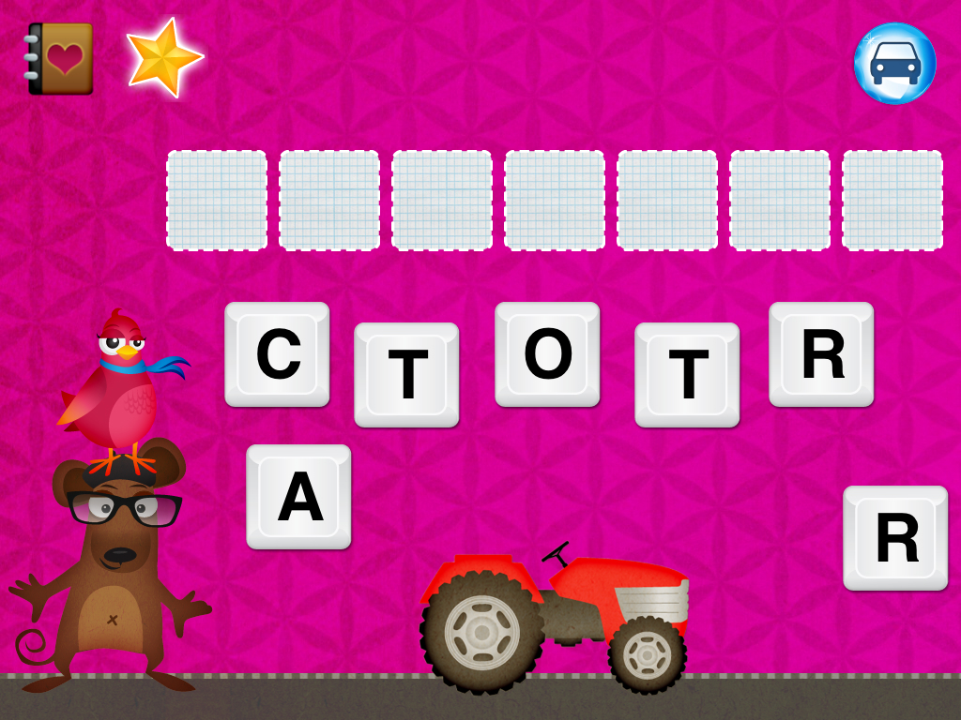

Figure : Word Wagon by Duck Duck Moose

### Sir Linkalot Spelling App

Sir Linkalot is a spelling app which teaches children how to spell word using mnemonics and memorizing words with stories. The app can be used by children to learn the following: spelling, homophones, rules & patterns, punctuation & grammar, and etymology (origin of words). This app also features memorable animations, quizzes and crosswords.

This app provides support for dyslexic children and is very effective for teaching children with special needs how to spell. It allows for parents/teachers to input custom word list for their wards to spell. Sir Linkalot is supported by iOS, Android, Amazon Kindle and Windows devices. It can also be projected onto a whiteboard. The app cost $9.62 per month for personal use and $2.75-$6.88 for student license. The app also offers free trials. This app has no reward system for getting spellings right. It does not give comprehensive feedback on the child’s performance. The default word list on the app were curated for the UK National Curriculum.

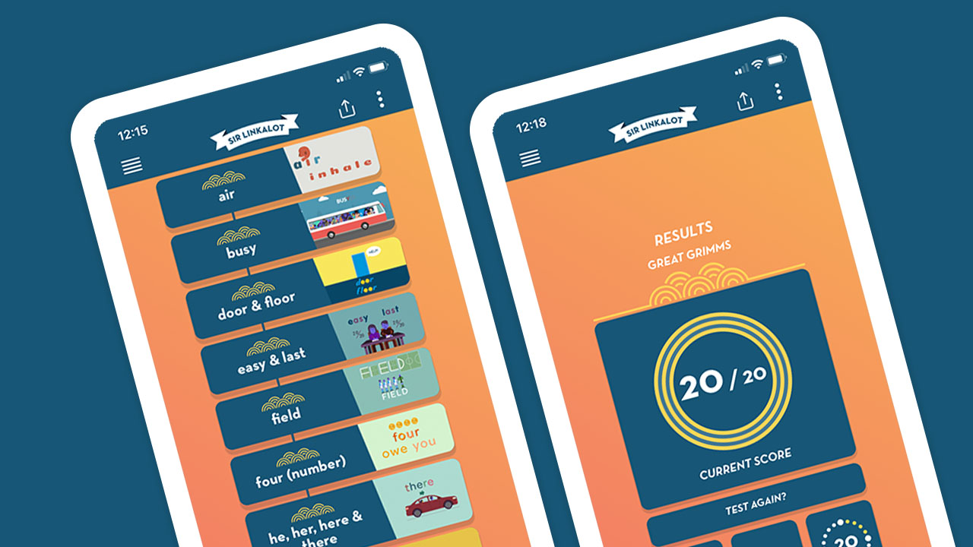

Figure : Sir Linkalot Spelling App

### Word Wizard for Kids

Word wizard for kids is a spelling app that teaches children spelling, phonics and short sentence making. Kids can spell their own words or sentences and hear them spoken back by a computerized voice on the open spelling board feature. It does not have perfect word-to-voice translator: Kids may misspell some words and still have them auto-pronounced correctly. This sometimes makes misspelling reinforced if children are not taught to know that the red glow around a word means it is misspelled.

Word wizard has a reward system for every right pronunciation or spelling. The app is quite customizable as users can set the pronunciation and tone to American or UK. It allows parents/teachers to create their own spelling list. Individual user data can be tracked as children are required to create a username.

The default word list is not curated from any recognized curriculum. It is available on only iOS devices and cost $4.99.

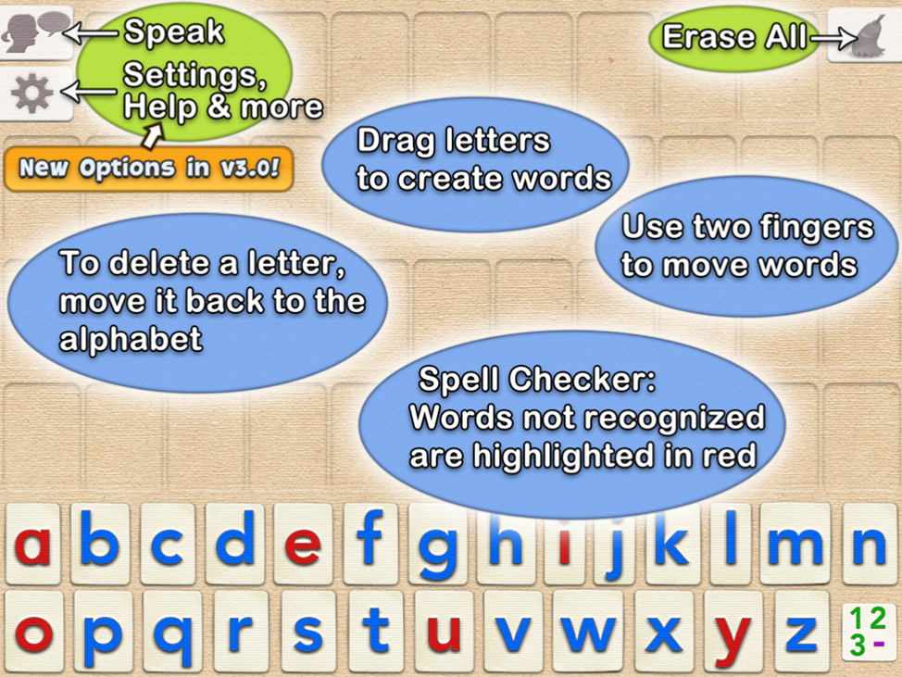

Figure : Word Wizard for Kids

## LITERATURE REVIEW

This section provides a review of existing systems that are related to the methodology used for the study.

### An Adaptive e-Learning System for Enhancing Learning Performance: Based on Dynamic Scaffolding Theory (Wu et al., 2018)

This project was created to explore the efficiency of an adaptive learning system that is built on user’s existing knowledge and set rules. The students selected suitable materials in line with their own objectives. The system was tested using 60 undergraduate students from a technology university, the results revealed that the system could effectively support learning. This result recommended the use of rules to assess students in an adaptive system to access students. The study revealed that the provision of additional support for the learner improved the learning experience of the learner. The limitation of this system is that it did not allow the instructor input materials based on learning goals therefore cannot be used amongst children.

### Enhancing Student’s Ability in Learning Process of Programming Language using Adaptive Learning Systems: A Literature Review (Anindyaputri et al., 2020).

The conclusion of this research was that sometimes the learning material can constitute extra workload so it should be made simple enough to consume in a short time. It reviewed various systems and only one of those systems could accommodate collaborative learning. The systems were able to adapt based on student’s knowledge, learning styles and behavior. It made use of questionnaire to examine student’s programming knowledge level and also uses an algorithm to track behavior. The limitation of the systems is that they do not support collaborative learning.

### An Adaptive Learning System based on Knowledge Level for English Learning (Sfenrianto et al., 2018).

This project is a learning system that uses the knowledge level of English learners to personalize their learning experience. The system suggests learning materials to users based on the knowledge level of the users. The learners are given a test to determine their level of proficiency, then the results of their test are used to organize them into elementary, intermediate, and advanced levels, respectively. Each of the level has specific rules that define them. The system was evaluated using 90 learners with varying English proficiency level. The result of this test shows that the system improved the learners to another proficiency level and reduced the percentage of the users in the elementary level. The system is limited in the sense that it does not allow instructors to input target materials.

## RELATED FINDINGS

A review of past literatures on the use of adaptive learning in improving the learner’s knowledge level has been carried out. Majority of the system do not allow instructors to input learning materials. One of them does not support collaborative learning, therefore cannot be used in a classroom setting. The system by Anindyaputri et al used rules to categorize learners and is the only one with characteristics that are remotely similar to the system this project intends to implement.

# REFERENCES

(AEDC), A. E. D. C. (2017). *The Australian Declaration for Young Children*. 1. https://colab.telethonkids.org.au/globalassets/subsite-media/subsite-documents/colab-documents/171123-australian-declaration-for-young-children.pdf

Adewusi, A., & Nwokocha, E. E. (2018). Maternal education and child mortality in Nigeria. *The Nigerian Journal of Sociology and Anthropology*, *August*, 111 – 130. https://doi.org/10.1016/j.jhealeco.2015.08.003

Anindyaputri, N. A., Yuana, R. A., & Hatta, P. (2020). Enhancing Students’ Ability in Learning Process of Programming Language using Adaptive Learning Systems: A Literature Review. *Open Engineering*, *10*(1), 820–829. https://doi.org/10.1515/eng-2020-0092

Baker, D. W., Parker, R. M., Williams, M. V., Clark, W. S., & Nurss, J. (1997). The relationship of patient reading ability to self-reported health and use of health services. *American Journal of Public Health*, *87*(6), 1027–1030. https://doi.org/10.2105/AJPH.87.6.1027

Baranek, L. K. (1996). *The Effect of Rewards and Motivation on Student Achievement*.

Campus Technology. (2016). *The Blurry Definitions of Adaptive vs. Personalized Learning*. https://campustechnology.com/articles/2016/12/20/the-blurry-definitions-of-adaptive-vs-personalized-learning.aspx

Dearing, E., Kreider, H., Simpkins, S., & Weiss, H. B. (2006). *Family involvement in school and low-income children’s literacy: Longitudinal associations between and within families*. *November*. https://doi.org/10.1037/0022-0663.98.4.653

Forsyth, B., Kimble, C., Birch, J., Deel, G., & Brauer, T. (2016). *Maximizing the Adaptive Learning Technology Experience*. *16*(4), 80–88.

Graham, S., & Miller, L. (1979). *Focus on exceptional children*. *12*(2).

Hodges, R. E. (1965). *The Psychological Bases of Spelling*. https://www.jstor.org/stable/41387552?seq=1

Homer Blog. (2020). *The Stages Of Spelling Development: A Guide For Parents*. https://blog.learnwithhomer.com/2020/11/23/stages-of-spelling-development/

Ingebrand, S. (2013). *Spelling as It Relates to Literacy: Reading, Writing, and Language*.

Institute of Medicine and the National Research Council. (2015). *Transforming the Workforce for Children Birth Through Age 8: A Unifying Foundation*.

Leahy, M. A., & Fitzpatrick, N. M. (2017). *Early Readers and Academic Success*. *7*(2), 87–95. https://doi.org/10.5539/jedp.v7n2p87

Learning, 3P. (2017). *The Importance of Spelling*. https://www.3plearning.com/blog/blog-importance-spelling/

Libraries 2020. (2020). *Report: The Connection Between Crime and Illiteracy is Clear!* https://www.libraries2020.org/crimereport

Matei, A., & Gogu, M.-C. (2017). Adaptive Education – a Systemic View. *EDULEARN17 Proceedings*, *1*(March), 766–772. https://doi.org/10.21125/edulearn.2017.1169

Moats, L. C. (2005). *How Spelling Supports Reading*.

Montgomery, D. J., Karlan, G. R., & Coutinho, M. (2001). *The Effectiveness of Word Processor Spell Checker Programs to Produce ’ Thrget Words for Misspellings Generated by Students with Learning Disabilities*. *16*(2), 27–42.

Moskal, P., Carter, D., & Johnson, D. (2017). 7 Things you should know about adaptive learning. *Educause Learning Initiative*, 2. https://library.educause.edu/resources/2017/1/7-things-you-should-know-about-adaptive-learning

National Literacy Trust. (2017). *What is literacy?* https://literacytrust.org.uk/information/what-is-literacy/

O’Cummings, M., Bardack, S., & Gonsoulin, S. (2010). *The Importance of Literacy for Youth Involved in the Juvenile Justice System*.

OECD. (2008). Understanding the Brain : the Birth of a Learning Science. New insights on learning through cognitive and brain science. *OECD/CERI International Conference “Learning in the 21st Century: Research, Innovation and Policy,”* 15. https://doi.org/10.1787/9789264029132-en

Pollo, T. C., Treiman, R., & Kessler, B. (2012). Three perspectives on spelling development. *Single-Word Reading: Behavioral and Biological Perspectives*, 175–189. https://doi.org/10.4324/9780203810064

Population Action International. (2011). *Why Population Matters to Education & Labor*.

Reading Rockets. (2021). *Spelling: In Depth | Reading Rockets*. https://www.readingrockets.org/teaching/reading101-course/modules/spelling/in-depth

Roman, S. P. (2004). Illiteracy and older adults: Individual and societal implications. *Educational Gerontology*, *30*(2), 79–93. https://doi.org/10.1080/03601270490266257

Roschelle, J. M., Pea, R. D., Hoadley, C. M., Gordin, D. N., & Means, B. M. (2000). Changing how and what children learn in school with computer-based technologies. *Future of Children*, *10*(2), 76–97. https://doi.org/10.2307/1602690

Sanchez, A. G. M., & Frandell, T. (2013). *Literacy from a Right to Education Perspective*.

Simonsen, F., & Gunter, L. (2001). *Best Practices in Spelling Instruction: A Research Summary*.

Tout, K., Halle, T., Daily, S., Albertson-Junkans, L., & Moodie Shannon. (2013). *The Research Base for a Birth through Age Eight State Policy Framework*. *April*.

University, W. (2021). *What’s the Importance of Early Childhood Education?* https://www.waldenu.edu/online-masters-programs/ms-in-early-childhood-studies/resource/what-is-the-importance-of-early-childhood-education

Victoria University. (2014). *iPads can help kinder kids learn, study finds*. https://www.vu.edu.au/news-events/news/ipads-can-help-kinder-kids-learn-study-finds

Wu, C. H., Chen, Y. S., & Chen, T. C. (2018). An Adaptive e-learning system for enhancing learning performance: Based on dynamic scaffolding theory. *Eurasia Journal of Mathematics, Science and Technology Education*, *14*(3), 903–913. https://doi.org/10.12973/ejmste/81061